Years 3–6
Blackett PS
Dharug Cluster

Mad Math Monday
Outcome: MS2.2, WMS2.2
Indicator: Estimate, measure, compare and record areas in square centimetres and square metres.
DK | DU | PK | HOT | M | SC
x
EQC | E | HE | SS | SSR | SD
 | x
BK | CK | KI | I | C | N
 |  |  |  | x
Quality Teaching:

Introduction:
- Dream Time Story
- Introduce question and discuss possible solutions

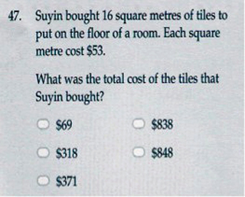

Body:
Students use a piece of paper and small coloured squares to tile the room remembering that the room is only 16m2. Paste tiles and add each tile to get total. For older students have them increase or decrease the room size or change the layout. How are we going to fine the area? What do we need to do first?

Conclusion:
Discuss the different ways you can work out the answer. Addition, multiplication, jump-strategy etc. Have students demonstrate how they achieved an answer.

Evaluation:

Mad Math Monday
Venus Special

Outcome: SGS1.3, WMS2.2
Indicator: making simple models from photographs, drawings or descriptions.
DK | DU | PK | HOT | M | SC
x
EQC | E | HE | SS | SSR | SD
 | x
BK | CK | KI | I | C | N
 |  | x
Quality Teaching:

Materials Needed: Foam ball per student, textas to colour, picture of Venus. If students paint they MUST wear a paint shirt.

Introduction:
- Dream Time Story
- Introduce activity and discuss what is happening to Venus and how it is moving. Why is it dangerous to look at the sun? What materials do we need? How do we know if it will fly or not? Show students a picture of Venus on the computer.


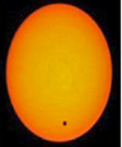

Body:
Students use materials to make their own representation of Venus.
It could be the sun with a dot to represent Venus or just Venus itself.
Conclusion:
Discuss the fact that this event is once in a lifetime and they will never see it again.

Evaluation:

What is the Transit of Venus???
A transit of Venus occurs when Venus is observed to move across the face of the Sun. The first transit since 1882 occurred on 8 June 2004. The next transit will occur on 6 June 2012, and be visible in Sydney from beginning to end, starting at 8.16am (1st contact) and ending at 2.44pm (last contact). The following transit of Venus won’t occur until 2117.

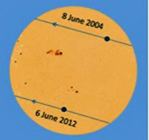

The safest way to watch a transit is to observe an image of the Sun projected onto a screen through a telescope, binoculars, pinhole or reflected pinhole. The event can be viewed without magnification using filters specifically designed for this purpose, such as an astronomical solar filter or eclipse viewing glasses coated with a vacuum-deposited layer of chromium. However, the disk of Venus is tiny compared to the sun and not much will be seen. The once-recommended method of using exposed black-and-white film as a filter is not now considered safe, as small imperfections or gaps in the film may permit harmful UV rays to pass through. Observing the Sun directly without appropriate protection can damage or destroy retinal cells, causing temporary or permanent blindness.

Mad Math Monday (May be 2 Lessons)
Outcome: SGS1.3, WMS2.2
Indicator: making simple models from photographs, drawings or descriptions.
DK | DU | PK | HOT | M | SC
 |  | x
EQC | E | HE | SS | SSR | SD
 | x |  |  |  | x
BK | CK | KI | I | C | N
Quality Teaching:

Introduction:
- Dream Time Story
- Introduce activity and discuss how we are going to make a kite. Do we need to measure and cut? What materials do we need? How do we know if it will fly or not?

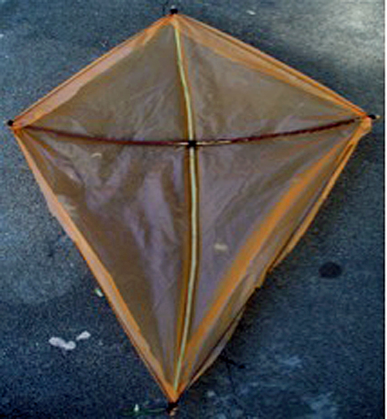

Body:
Students use materials to make their kite in pairs.
Take students outside to test out their kites. Whose kite can fly? Who needs to reconsider their design?

Conclusion:
Discuss ways you can improve your design. Materials? Shape?

Evaluation:

Mad Math Monday
Olympic Games – Cathy Freeman

Outcome: SGS2.3, WMS2.2
Indicator: Making simple models from photographs, drawings or descriptions.
DK | DU | PK | HOT | M | SC
 |  | X
EQC | E | HE | SS | SSR | SD
 | X
BK | CK | KI | I | C | N
 | X
Quality Teaching:

Materials Needed: Array of photographs of Cathy Freeman, scissors, glue and coloured paper.

Introduction:
- Discuss who Cathy Freeman is and why she is famous.
- Introduce activity allocating pictures to students and explaining that they are going to rule lines across the picture 2cm by 2cm and cut them out. Students are then going to cut out the squares and paste with spaces in between on the coloured paper.

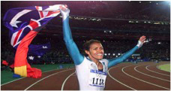

Cathy Freeman – Olympic Gold Medallist - Runner

Body:
Students use materials to create pictures out of squares.
Conclusion:
Discuss the upcoming Olympic games and the fact that they are being held in London this year.

Evaluation:

Cathy Freeman
Catherine Astrid Salome "Cathy" Freeman, born 16 February 1973, is a former Australian sprinter, who specialised in the 400 metres event. She became the Olympic champion for the women's 400 metres at the 2000 Summer Olympics, at which she lit the Olympic Flame. Freeman was the first ever Aboriginal Commonwealth Games gold medalist at age 16 in 1990. 1994 was her breakthrough season. At the 1994 Commonwealth Games in Canada, Freeman won gold in both the 200 m and 400 m. She also won the silver medal in the 1996 Olympics and came first at the 1997 World Champion in the 400 m event. 1998 saw Freeman taking a break from running due to injury. She returned to form with a first place in the 400 m at the 1999 World Championships. She announced her retirement from athletics in 2003.
Freeman was born in Slade Point, Mackay, Queensland, where the local athletics track is now named after her. Her coach throughout her athletic career was Peter Fortune. In 1999, she married Sandy Bodecker, separating in February 2003. In 2009, she married James Murch, with whom she gave birth to a girl in 2011. In 1998, she was awarded Australian of the Year, in 2001 the World Sportswoman of the Year and the Medal of the Order of Australia.

Mad Math Monday
Olympic Games – Biography
Outcome: DS2.1
Gathers and organises data, displays data using tables and graphs, and interprets the results

DK | DU | PK | HOT | M | SC
EQC | E | HE | SS | SSR | SD
BK | CK | KI | I | C | N
Quality Teaching:

Materials Needed: Butchers paper, textas, tape measures, scales, metre rulers

Introduction:
- Discuss who Damien Hooper is and what he is famous for. What is he competing in, in London?
- Introduce activity discussing Damien’s age; weight, height etc… have students complete a biography of themselves; recording their age, weight and height.



Damien Hooper
Olympic Boxer

Body:
Have them work in pairs to trace the outline of their bodies on butcher’s paper. Measure the height of their outline and compare it to measurements when standing, are they different? If they stretch their arm out does the length and width of their bodies make a square? Discuss and record answers and observations in their booklets.

Conclusion:
Discuss the results and how they vary for each student. Collect books and pack up.

Evaluation:

Born: February 1992
TOOWOOMBA, QLD
Australia
Australian Institute of Sport (AIS) boxer Damien Hooper is a young man on the rise whose ambition to reach the top in his profession has no boundaries or limits.
The 18-year-old openly talks about his desire to one day become a professional world champion and, given his achievements within the amateur ranks, few would doubt his ability to reach those lofty heights.
Damien became the first Indigenous boxer to win a junior world event when claimed gold at last month’s Youth Olympic Games in Singapore. He comfortably beat Columbian Juan Carlos Carrillo 12–4 to win the 75kg middleweight title.
He heads into competition at the Commonwealth Games in Delhi as a boxer tipped to be amongst the medals.
‘Damien has a very good chance of a medal, probably our best chance, despite his age,’ AIS and national assistant coach Don Abnett said.
‘It’s going to be a tough division for him with the Indian boy Vijender Singh, who is ranked the number one senior middleweight in the world, in there. But anything is possible with Damien, he is very talented and, like a lot of Indigenous fighters, has an awkward but unique style as he hits his opponents with some interesting combinations.’
‘A lot of the drills he does he’s worked on himself, they have not come from me, he is a real talent. I have been a coach since 1981 and there are probably only ten really outstanding boys that I have seen in that time and Damien is one of them.’
Abnett believes with the right attitude and commitment Hooper is capable of winning a medal at the London 2012 Olympic Games.

Questions & Answers
- What is your most significant achievement in sport?
Silver medal at the 2010 Youth World Championships
- What is your major sporting goal?
Full name: Damien Hooper
Nationality: Australian Aboriginal
Born: 5 February 1992 (age 20)
Toowoomba, Queensland
Height: 1.80 m (5 ft 11 in)
Weight: 80 kg (180 lb)
Sport: Boxing Rated at Light Heavyweight
Club: Australian Institute of Sport

